The role of deeper layer neck muscles on the cervical dystonia treatment – a case report
Caio Ribeiro Azevedo Gomes ª *, Carmen Caroline Orru ª, Fabiola Cavalieri ª, Arquimedes de Moura Ramos ª, Tae Mo Chung ª
ª Institute of Physical Medicine and Rehabilitation at the Hospital das Clínicas of the Faculty of Medicine of the University of São Paulo (HC-FMUSP) and Institute of Neurorehabilitation (INERE).
* E-mail: caioragomes@gmail.com; caio.gomes@hc.fm.usp.br
Address: R. Martiniano de Carvalho, 864 - 16 andar, Conj. 1604 - Bela Vista, São Paulo - SP, 01321-000

Keywords: cervical dystonia; botulinum toxin; anterocollis; longus colli; longus capitis
Introduction
Cervical dystonia is the most common form of focal dystonia ^{1,2} and can be characterized as involuntary and sustained contractions of the neck muscles, causing abnormal postures of the whole cervical region ^{2, 3, 4, 5}.
Botulinum toxin (BoNT) injection is the treatment of choice for this condition, achieving a satisfactory result in 80-85% of patients ^{1, 2, 3}. Currently, most centers use anatomical landmarks techniques for injection with or without the aid of other auxiliary methods ^{1, 2, 3, 4, 6}.
On dystonic patterns that generate neck flexion (around 25% of the cervical dystonia patients) ³, functional studies point to an important role of the deep layer muscles (like, Longus Capitis and Longus Colli) ^{2,3,7}.
The Longus Capitis and Longus Colli are located on the antero-lateral surface of the cervical spine, and their position poses a challenge when planning the treatment of cervical dystonia patients.
Case Presentation
A 42-year-old male presents to our clinic complaining of difficult of speech and cervical pain for 14 years with associated involuntary movement of the head. He had 3 applications of botulinum toxin, with a different care provider, with mild improvement, however, no deeper layer muscles were ever target on these occasions.
Upon physical examination, he presented with the anterocollis/anterocaput form of cervical dystonia and dysphonia with the adductory pattern (Picture 1).
Clinical examination and EMG testing were conducted to assess the activated muscles. With the aid of the EMG guidance, the point of access and depth of the longus capitis and longus colli were then established for the injection. The muscles found to be generating the patient’s pattern are described on the table below (Table 1), with the toxin botulinum dosage used on each of them. Although other muscles were addressed after the electroneuromyographic confirmation of their dystonic activation and their contribution to the patient’s pain and dysphonia, the only muscles targeted that contribute to the anterocollis and anterocaput posture, according to the literature, are the longus capitis and longus colli muscles. ⁸

Table 1 – Muscles treated and dosage (Onabotulinumtoxin A).
Right | Muscle | Left
30 U | Splenius Capitis | -
- | Semiespinalis Capitis | 30 U
40 U | Longus Capitis | 40 U
30 U | Longus Colli | -
3 U | Thyreoaritenoid | 3 U
20 U | Sternohyoid | 20 U
- | Sternothyroid | 10 U
- | Thyrohyoid | 10 U
10 U | Digastric | -
18 U | Platysma | 18 U

Upon his first consultation one month after botulinum toxin injection, he reported improvement in his swallowing, speech and neck pain. His anterocollis angle also improved and no major side effects were reported.
On his second visit (4 months after the botulinum toxin injection), most of his improvement was sustained, as shown in the picture below (Picture 2).

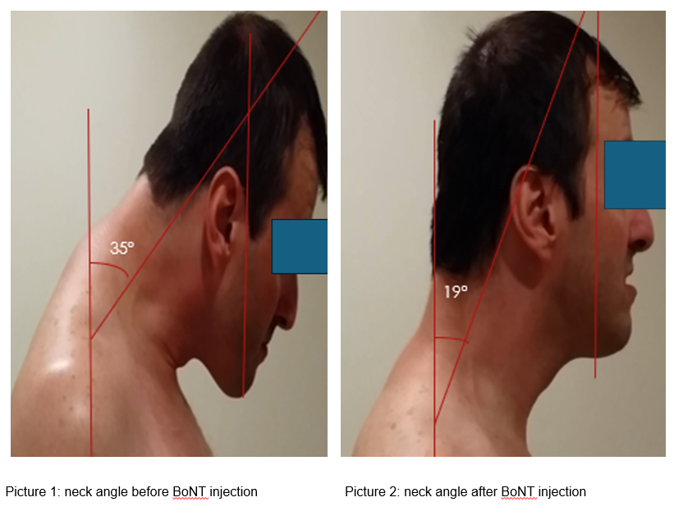

Discussion
Role of Deep Flexors in Anterocollis and Anterocaput
Although traditionally mentioned as contributors to the anterocollis and anterocaput postures, longus capitis and longus colli ⁸ are seldom targeted due to technical difficulties.
As the use of auxiliary methods (EMG and USG) become significantly more widespread, a larger number of centers are considering the injection of deeper layer muscles for the treatment of cervical dystonia. It is our understanding that seeing the success of this patient will increase the level of confidence of our colleagues to try this approach.
Several techniques have been proposed to aid the injection of longus capitis and longus colli ^{9,10}.

Conclusion
This case demonstrates that targeted BoNT-A injections into longus capitis and colli, can significantly improve anterocollis/anterocaput and related symptoms in refractory cervical dystonia with minimal side effects. It reinforces emerging best practices and highlights the need for clinician training in the deeper layer muscles injection techniques to treat complex dystonic patterns.
References
1 Xu C, Xue F, Chang W et al. Botulinum toxin type A with or without needle electromyographic guidance in patients with cervical dystonia. SpringerPlus (2016) 5:1292
2 Allison SK, Odderson IR. Ultrasound and electromyography guidance for injection of the longus colli with botulinum toxin for the treatment of cervical dystonia. Ultrasound Quartely 2016; 00:00-00.
3 Glass GA, Ku S, Ostrem JL et al. Fluoroscopic, EMG-guided injection of botulinum toxin into the longus colli for the treatment of anterocollis. Parkinsonism and Related Disorders 15 (2009) 610-613.
4 Flowers JM, Hicklin LA, Marion MH. Anterior and Posterior sagittal shift in cervical dystonia: a clinical and electromyographic study, including a new EMG approach of the longus colli muscle. Movement Disorders, Vol. 26, No.13, 2011.
5 Nijmeijer SWR, Koelman JHTM, Kamphuis DJ et al. Muscle selection for treatment of cervical dystonia with botulinum toxin – a systematic review. Parkinsonism and Related Disorders 18 (2012) 731-736.
6 Herting B, Wunderlich S, Glockler T et al. Computed tomographically-controlled injection of botulinum toxin into the longus colli muscle in severe anterocollis. Mov Disord. 2004; 19(5): 588-590.
7 J. Finsterer, et al., Collum-caput (COL-CAP) concept for conceptual anterocollis, anterocaput, and forward sagittal shift, J Neurol Sci (2015), http://dx.doi.org/10.1016/j.jns.2015.06.015

8 Jost WH, Tatu L. Selection of Muscles for Botulinum Toxin Injections in Cervical Dystonia, MOVEMENT DISORDERS CLINICAL PRACTICE (2015)

9 Farrell M, et al. Management of anterocapitis and anterocollis: a novel ultrasound-guided approach combined with electromyography for BoNT injection of longus colli and capitis. Toxins (Basel). 2020;12(10):626.

10 Hicklin LA, et al. Ultrasound Study to Validate the Anterior Cervical Approach to the Longus Colli Muscle Using Electromyography Control Alone. Tremor and Other Hyperkinetic Movements. 2020; 10(1): 35, pp. 1–6. DOI: https://doi.org/10.5334/tohm.545

